Proposal

Computing Project

Project Title: Digital Voting System



Name: Dipak Shah

ID: 00175073

Level 5 Diploma in Computing

Softwarica College of IT ₰ E-Commerce

Kathmandu, Nepal

01/04/2019

Table of Contents

**1.** **INTRODUCTION** 3

**Project Introduction** 3

**1.1** **Justification of the project** 4

**Background of project** 4

**1.2** **Problem statement** 5

**1.3** **Description of the project** 6

**1.4** **Overview of the project** 7

**2** **Scope of the project** 7

**2.1** **Scope and limitation** 7

**2.2** **Aims and Objectives** 8

**3** **Development methodology** 9

**3.1** **Waterfall model** 9

**3.2** **Design patterns** 11

**3.3** **System architecture** 12

**4** **Project plan: - Work Breakdown Structure (WBS)** 13

**4.1** **Work Breakdown Structure** 13

**4.2** **Milestones** 14

**4.3** **Scheduling: GANTT CHART** 15

**Time Estimation Table** 15

**GANTT CHART** 16

**5** **Risk management** 17

**6** **Configuration Management** 21

**7** **Conclusion** 24

**8** **References** 24

# **INTRODUCTION**

## **Project Introduction**

In the current world, technology have taken an essential part of the people and being without technology would be an unimaginable life. People wants an easiest way to communicate and sharing information as quickly as possible. Technology makes business more productivity applying automation. Bill Gates say’s that “The first rule of any technology used in a business is that automation applied to an efficient operation will magnify the efficiency. The second is that automation applied to an inefficient operation will magnify the inefficiency.”

Some of the countries apply the election system online to make secure and more efficient but Often must of the countries have traditional rules for election that makes people feel more stress to stand on long queue to give a vote.

I must have a plan to build an Online Voting System (Online Election System) as a web application to make people easier to cast vote and provide a high level of security to protect the voting System.

## **Justification of the project**

## **Background of project**

Online Voting System is a web application in which we give vote to the specific party sign. This web application also for all the people those who have not present in the specific country. They can also give a vote to the specific party sign through online if they have voter card number.

In this system, Admin can add the candidate and the specific party sign, and this is only authorized by administrator. Voters can login with register first with full of details and then give a vote to the specific party.

This web application has also extra features like rules and regulation page to help the voters and instruct them that how to vote. Voters can also give feedback into the review form. I must also include an image gallery of the traditional rules of election system that you access without login and many more other features are available.

This web application is a fully responsive and support in the mobile phone also. I have also use guard system in the login for voters in which if voters can login failed 3 times it will be disable for the 3 minutes and use many more other high-level securities for the system.

## **Problem statement**

Online Voting System is the web application with the various features. This system allows voters to register account and give the vote online to the specific party sign easily. The whole system controlled by the system administration and add and remove the candidate. However,

During the process of voting system might be many problems occurred while voters can login into the system, they faced security problems. Security might be the main problem in the system and other many problems may be arise like problems in voters register form. May be error in content management system store in a database that is holding all the information about voters and vote. Voters password might be hacked etc.

I must prepare a best planning to overcome all the arises problem in the system. Mainly I must focus on the security of this system, I must create different guard system to the login and register form and password of the voters should be encrypted form. And include a backup system for the future documentation.

## **Description of the project**

**Features**: there are so many key features of the system some are follow points.

1. **Admin login form: -** After login, admincan able to add, remove, update and delete candidate and post a news and updated rules.
2. **Voters register and login form: -** voters can register their account and login with username and password and then access to the voting system.
3. **Voters can give their opinion in review form: -** Voters can give their opinion of that how much satisfied with the new system of Online Voting System.
4. **Newsletter Form and contact from: -** voters can allow todirectly contact to the administration from contact form available in main page of website. Newsletter from also available to stay with the latest news to the administration.
5. **Image slider and image gallery of traditional voting system: -** In this website I must create a beautiful image slider in the beautiful landing page. I must create an image gallery including the older voting system images of nepal.
6. **News, upcoming Events, new rules and regulation of voting system and blogs: -** these features allow to voters for more awareness to the system and new rules or events posted by the admin.

## **Overview of the project**

Digital Voting System is the finally a totally features added and responsible web application in which we give vote online to the specific party sign. Many other features are also available with the interactive web pages. Using this website people can be more satisfy and feel pressure less life.

# **Scope of the project**

## **Scope and limitation**

**Scope**

This project will consist of creating a digital voting system in the based of web application. The project will be completed by July 2019. Digital Voting System include the system in which voters can vote to the any party sign online simply registering your citizenship number and voter card number. This website application builds for making people more modern and sustain stress less life.

**Limitation**

Some limitation of this project is given below:

1. Finger print system and retina scan system cannot include in this web application therefore, privacy is not secure.
2. Due to its unsecure privacy it is danger from hackers and cannot include a top level of security.

## **Aims and Objectives**

**Aims**

The main intention of creating Digital Voting System is to provide service to the voters in which voters can easily cast vote online with the maintaining privacy. Using this process/way of voting system is more secure than traditional method and easier or stress less way of voting.

**Objectives**

There are many objectives of this project the main objective is that control the entire voting system to protect from hackers. Voters information should be store in database and controlled by the administration.

Some objectives of this project are given below:

1. Easy and user-friendly environment for the interaction of the voters.
2. Provide registering functionality for all the voters that are eligible to vote and at the same time, provide them with unique identification (password and smart card, etc.) that will allow the system to check the voters by validating their credentials/identification.
3. Automatic generation of the vote count and expose results.

# **Development methodology**

## **Waterfall model**

I must use waterfall model in my project (online voting system). Waterfall model is a sequential design process of software development in which progress is seen as following steadily downwards (like waterfall) through the following SDLC (software development life cycle) steps (definitions.net, 2019):

1. **Analysis and requirements**
2. **Design**
3. **Implementation/coding**
4. **Testing**
5. **Deployment**
6. **Maintenance**

This process of software development steps only starts when the previous steps is finished.

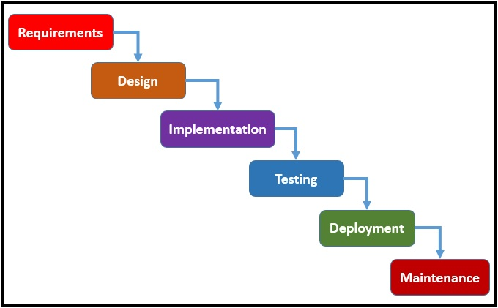

Figure 1waterfall model

**Advantages of using waterfall model in software development are given below:**

1. Simple and easy to understand and use.
2. Phases are processed and completed one at a time.
3. Clearly defines milestone and deadlines.
4. Supports good coding habits to define before design and then code.

## **Design patterns**

Design pattern is a written document that describes a general solution to a design problem. Its main proposed is to give solution for the arises problems in the system design (Rouse, 2019). There are many design patterns, I must use MVC (Model View Controller) design pattern to solve the arises problems in the design phase.

**Advantages of MVC design pattern**

1. Faster development process (MVC support rapid and parallel development),
2. Ability to provide multiple views,
3. Support for asynchronous technique,
4. Modification does not affect entire model.

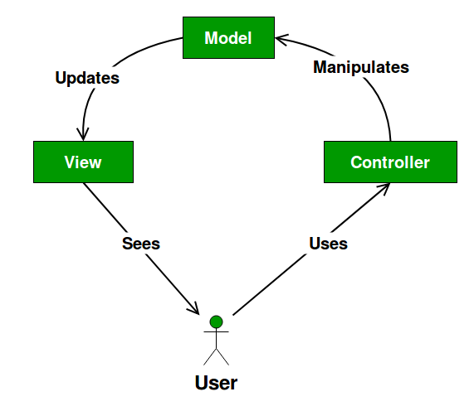

Figure 2 MVC design pattern

**Model: -** Models handles the state of the application (forum, blog, login form etc.) it supplies just ways of query the state and ways to change that state.

**View: -** View handles the UI (user interface) in application.

**Controller: -** user action on the view are send to the controller and translate into action in controller. It handles the interaction between model and view.

## **System architecture**

System architecture is a diagrammatically representation of the system’s views/views point, construction and model and modeling of the related system (mitre, 2019). I must use 3-tier structure for my system.

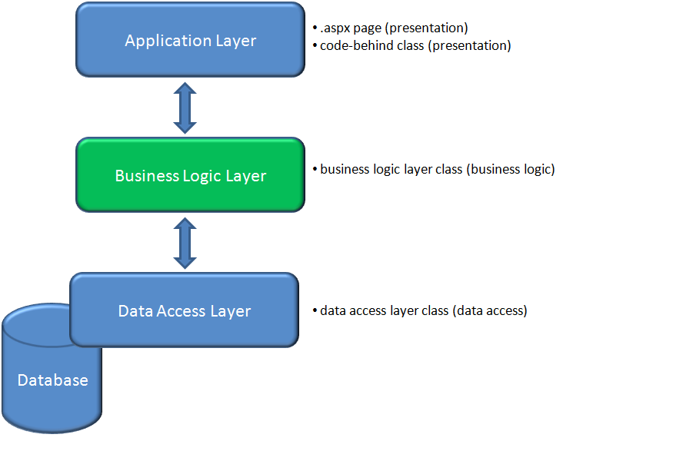

Figure 3 3-tire system architecture

# **Project plan: - Work Breakdown Structure (WBS)**

## **Work Breakdown Structure**

Work Breakdown Structure is simply a process to decomposition of the work to be executed by the project team. As each level of project of the work breakdown structure provides further information and definition (workbreakdownstructure, 2019).

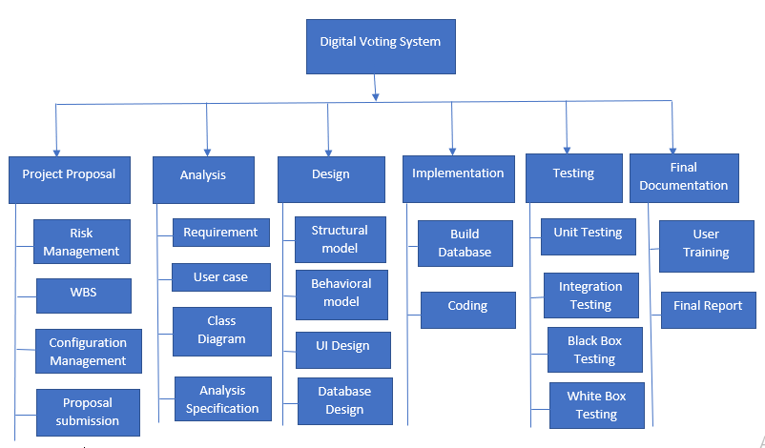

Figure 4 Work Breakdown Structure

## **Milestones**

Milestone are tool used in project management to mark specific points along a project timeline. I must also create a timeline for my project digital voting system.

|  |  |  |
| --- | --- | --- |
| **WPS** | **TASK NAME** | **NUM. OF DAYS** |
| 0 | ONLINE VOTING SYSTEM | 107 DAYS |
| 1  1.1  1.2  1.3  1.4 | **PROJECT PROPOSAL**  Risk Management  WBS  Configuration Management  Proposal submission | 16 DAYS  5 days  3 days  5 days  3 days |
| 2  2.1  2.2  2.3  2.4 | **ANALYSIS**  Requirement  User case  Class diagram  Analysis specification | 16 DAYS  6 days  2 days  4 days  4 days |
| 3  3.1  3.2  3.3  3.4 | **DESIGN**  Structural model  Behavioral model  UI Design  Database design | 25 DAYS  5 days  5 days  9 days  6 days |
| 4  4.1  4.2 | **IMPLEMENTATION**  Build Database  Coding | 20 DAYS  5 days  15 days |
| 5  5.1  5.2  5.3  5.4 | **TESTING**  Unit Testing  Integration Testing  Black box Testing  White box Testing | 7 DAYS  3 days  2 days  1 day  1 day |
| 6  6.1  6.2 | **FINAL DOCUMENTATION**  USER MANUAL  Report | 11 DAYS  5 days   1. days |

## **Scheduling: GANTT CHART**

### **Time Estimation Table**

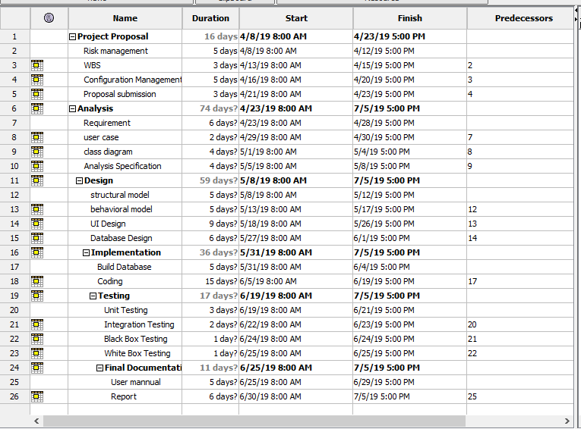

Figure 5 days divide for each task

### **GANTT CHART**

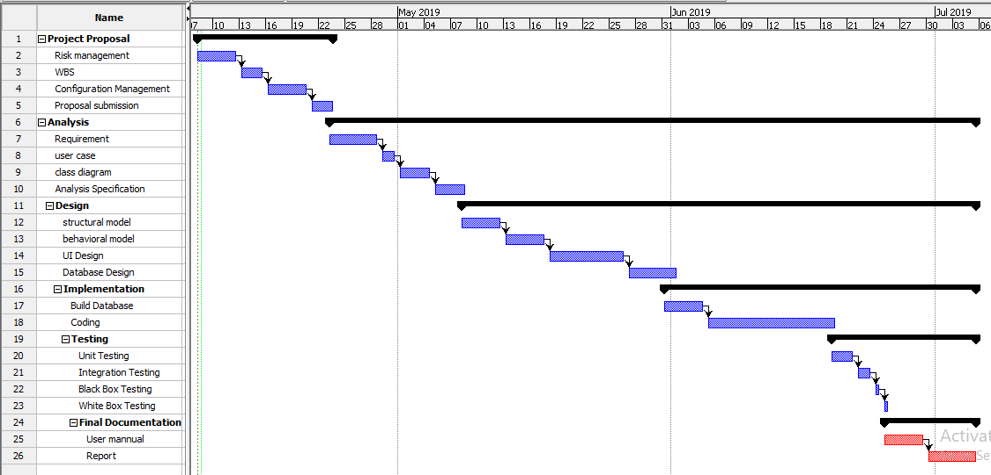

Figure 6 GANTT CHART of Digital voting System

# **Risk management**

Risk management is the process of identifying, accessing and controlling threats occur in the system/project. There are many risk management types used by the organization like risk assumption, risk avoidance and risk retention etc. (businessdictionary, 2019)

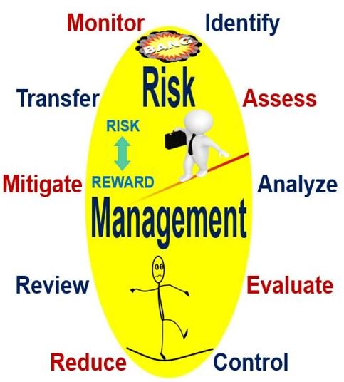

**Following are the threats may be occurred in digital voting system:**

1. Server failure
2. Phishing attack
3. Hard disk crash
4. Interruption of voting processes
5. Malicious
6. Loss of power supply
7. D-Dos and Dos attack
8. Time estimation problem

**Impact= Likelihood*Consequences**

**Values of Likelihood**

|  |  |
| --- | --- |
| **Likelihood** | **Values** |
| Low | 1 |
| Medium | 2 |
| High | 3 |

**Values of Consequences**

|  |  |
| --- | --- |
| **Consequences** | **Values** |
| Low | 1 |
| Very-Low | 2 |
| Medium | 3 |
| High | 4 |
| Very-High | 5 |

**Risk Likelihood and Consequences values (Likelihood*Consequences)**

|  |  |  |  |  |  |
| --- | --- | --- | --- | --- | --- |
| **S. N** | **Risks** | **Likelihood** | **Consequences** | **Impact** | **Solution** |
| 1 | Server failure | 1 | 4 | 4 | Proper Back up system should be done. |
| 2 | Phishing attack | 2 | 4 | 8 | Keep browser up-to-date timely. |
| 3 | Hard disk crash | 2 | 5 | 10 | Frequently checking and maintenance the whole physical component. |
| 4 | Interruption of voting processes | 2 | 3 | 6 | Proper management of network and Use firewall and pack sniffing technique for controlling high packet traffic. |
| 5 | Malicious | 3 | 3 | 9 | Install trusted anti-virus. |
| 6 | Loss of power supply | 2 | 5 | 10 | Backup system should be installed. |
| 7 | D-Dos and Dos attack | 1 | 3 | 3 | Use software called spam filter, anti-malware and anti-spyware for protection of email and safe from viruses. |
| 8 | Time estimation problem | 2 | 3 | 5 | Proper division of each work day. |

# **Configuration Management**

Configuration management is the practice of process of changing the system as systematically with the main propose in the both hardware and software. Updating is also possible while maintaining system integrity. It implements detailed strategies, technique and procedure while implement a good configuration tools to manage revisions, track revision status and document.

**Successful configuration management outcomes following advantages:**

1. Improved performance
2. Lower provability of error
3. Enhance online availability

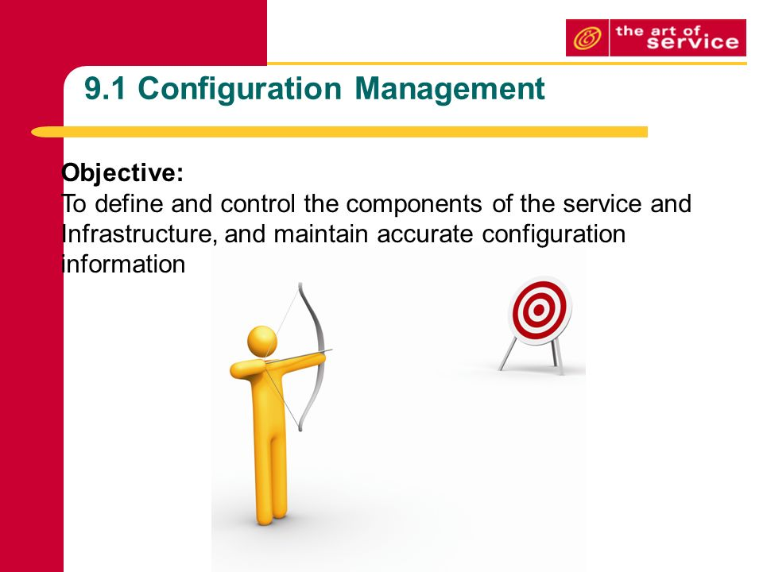

Figure 7 Configuration Management

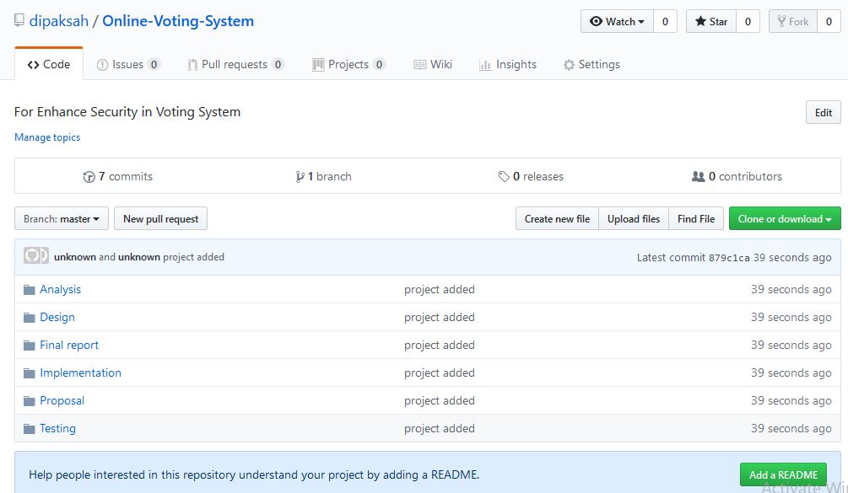

Figure 8 uploaded in GitHub

GitHub---URL---https://github.com/dipaksah/Online-Voting-System

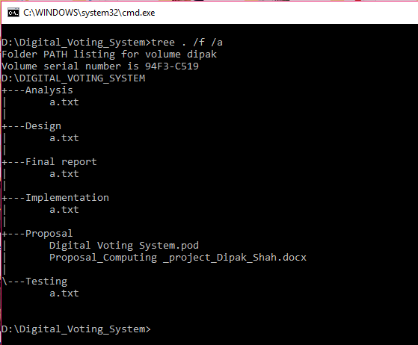

Figure 9 WBS tree structure

# **Conclusion**

Digital voting system is a user friendly and interactive web application in which people can cast vote online simply register their voter card number. Using this system people can feel more better and I hope that this web application is more enjoyable with the latest news on voting system. People will be more modern using this system and I hope this system can be liked by many people.

# **References**

businessdictionary. (2019).Retrieved from http://www.businessdictionary.com/definition/risk-management.html

definitions.net. (2019). Retrieved from https://www.definitions.net/definition/waterfall%20model

mitre. (2019). Retrieved from https://www.mitre.org/publications/systems-engineering-guide/se-lifecycle-building-blocks/system-architecture

Muslihat, D. (2018, march 2). Retrieved from https://zenkit.com/en/blog/agile-methodology-an-overview/

Rouse, M. (2019). Retrieved from https://searchsoftwarequality.techtarget.com/definition/pattern

workbreakdownstructure. (2019). Retrieved from https://www.workbreakdownstructure.com/